Generating queries in SQL
Print a list of doctors at a given hospital
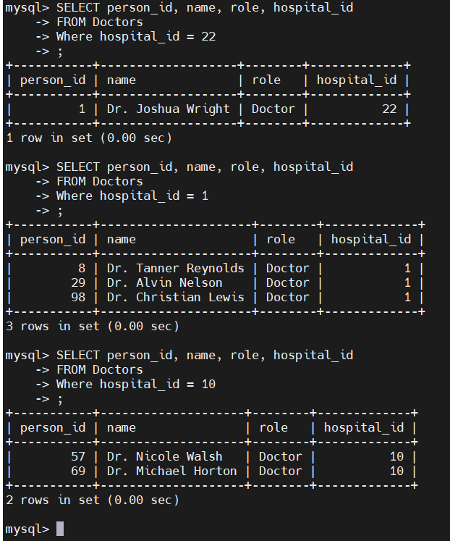

Print a list of all prescriptions for a particular patient, ordered by the prescription date
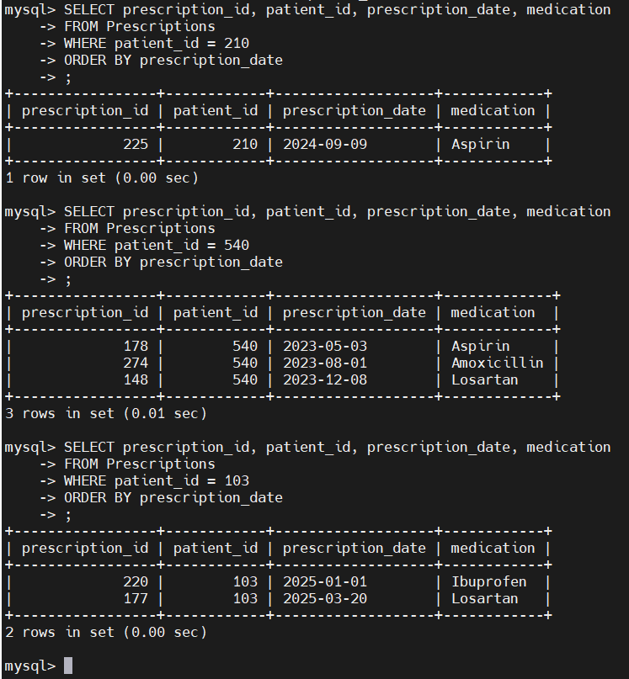

Print a list of prescriptions that a doctor has prescribed
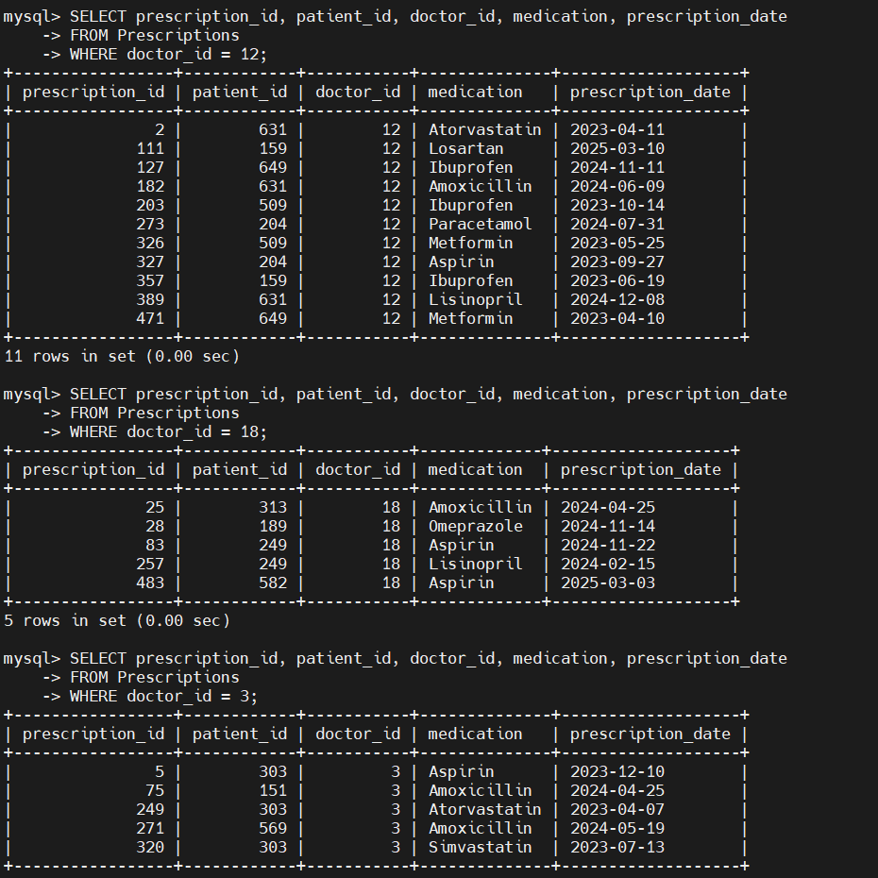

Add a new patient to the database, including being registered to one of the doctors
#from the doctors table identify person_id and matching hospital_id
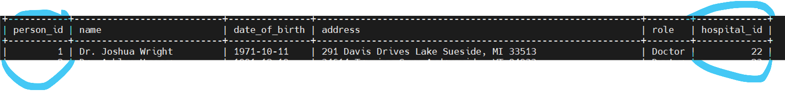
#define what information is needed to add patient into Patients table , to creat information for the patient you want to insert

#Add patient to the Patients table + check inserted

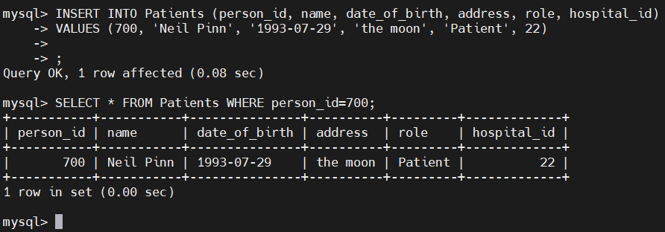

Print which doctor has made the most prescriptions
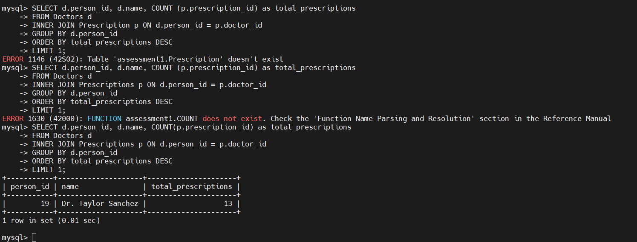

Print a list of doctors at the hospital with the biggest size
